Chapter 3, Solution 42

Although there are many ways to work this problem, this is an example based on the same kind of problem asked in the third edition.

Problem

Determine the mesh currents in the circuit of Fig. 3.88.

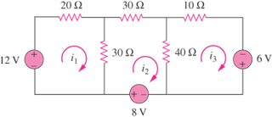

Figure 3.88

Solution

For mesh 1,
(1)
For mesh 2,
(2)
For mesh 3,
(3)
Putting eqs. (1) to (3) in matrix form, we get

Using Matlab,

i.e. I₁ = 480 mA, I₂ = 400 mA, I₃ = 440 mA

